

Prepared by:
Ivan Damnjanović
Founder & CEO
Ambient Systems
Date: January 20th, 2024

Prepared Exclusively for: Hong Kong Science & Technology Park

Executive Summary

In the dynamic landscape of Hong Kong's financial sector, Ambient Systems has identified an opportunity to advance financial performance of businesses through strategic research and development (R&D) collaboration with Hong Kong Science and Technology Parks Corporation (HKSTP). Ambient Systems aims to bridge the gap left by existing ERP and FP&A platforms by integrating cutting-edge artificial intelligence (AI) into an adaptable cross-border cloud-based software platform tailored for needs of future sustainable finance.

Ambient Systems proposes a partnership with HKSTP to further pioneer advancements in financial technology through R&D. Leveraging the expertise and resources of HKSTP, we envision a comprehensive R&D initiative that pushes the boundaries of what is possible in financial technology. By combining Ambient Systems advances in technology for financial management with HKSTP's innovative ecosystem, we seek to conduct ground-breaking new development that addresses current limitations among the current solutions for improving financial performance.

Current solutions like ERP and FP&A software falter in cross-compatibility with financial systems in China and globally. At the same, advanced analytics and machine learning solutions take a long time to implement or are difficult to develop without an in-house AI team, which is hard to justify economically for most companies.

In response, Ambient Systems will prioritize technical R&D efforts to extend the current cloud-based architecture towards greater data compatibility, streamlined regulatory compliance, and AI-driven speed to results. In addition, Ambient sees two market-specific solutions specific to Hong Kong. These include cross-border data considerations and regulatory compliance. The emphasis on research in these two domains – technical and market-specific – aims to not only address current market demands but to anticipate and lead future developments in financial technology.

Moreover, our R&D collaboration extends to empowering businesses in sectors traditionally overlooked by existing ERP and FP&A solutions. Sectors such as commercial real estate, construction, and transportation will be the focal point of research efforts, tailoring our solution to their unique planning requirements in Hong Kong and GBA. Given the substantial contribution of these industries to the economic growth to Hong Kong and nearby emerging economies, this strategic focus positions us for rapid growth in a symbiotic partnership.

The proposed collaboration with HKSTP, anchored in R&D excellence, serves as a testament to our shared vision of redefining the financial management landscape in Hong Kong and projecting the company onto the global stage. Beyond meeting immediate market demand, Ambient Systems and HKSTP aspire to establish a new global standard by actively contributing to the evolution of financial technology through cutting-edge research and development initiatives.

Section 1: Products & Solutions to Be Developed

Concept, Features, and Application
Ambient Systems envisions a new era of financial management, where data-driven insights and seamless integration empower businesses to optimize their financial performance while keeping in mind the latest advances in sustainability. Our cloud-based Financial Management Software harnesses the power of artificial intelligence (AI) and the Internet of Things (IoT) to redefine financial operations and drive business growth while focusing on sustainability.

Key Features
The product incorporates various features to meet the specific needs of finance teams involved in driving improvements in business performance. These are the key components and functionalities:

Feature | Description
Financial Analysis Module | Advanced financial modeling tools for projecting cash flow revenues and expenses across department units, assessing capital needs and ROI for new investments, and conducting scenario analyses specific to sustainability projects.
Resource Allocation and Budgeting Module | Tools for optimizing resource allocation, budgeting, and real-time tracking of expenditures for sustainability initiatives.
Reporting and Analytics Dashboard | Customizable dashboards for real-time visibility into financial performance metrics, KPIs, and progress toward sustainability goals.
Sustainability Metrics Integration | Tools to seamlessly integrate sustainability metrics, including ESG criteria, into the financial reporting framework. Ensure compatibility with industry standards and reporting frameworks.
Advanced Technology Integration | Leverage advanced technologies, such as artificial intelligence (AI) and Internet of Things (IoT) for predictive analytics and pattern recognition. Explore blockchain for transparent and secure tracking of sustainability data.
User-Friendly Interface | An intuitive and user-friendly interface to facilitate ease of use and adoption. Consider customization options to align with the workflows of finance professionals.
Scalability and Flexibility | Design the platform to be scalable to accommodate the evolving needs of growing organizations. Ensure flexibility to adapt to changes in sustainability regulations and reporting requirements.
Data Security and Compliance Features | Robust data security measures to protect sensitive financial and sustainability data. Ensure compliance with relevant regulations and standards governing financial reporting and sustainability practices.

Target Use Case Benefits
Ambient Systems is designed for finance teams across specific industries with the goal to help them quantify their financial performance targets and improve them while maintaining sustainability. We focus on industries that have the greatest potential to contribute to economic growth and low carbon future:
- Commercial Real Estate: empower real estate developers and owners to manage complex multi-location facility management operations, optimize revenue generation strategies, and achieve decarbonization and net zero targets by planning new investments through comprehensive real estate financial management tools.
- Transportation: empower transportation managers to streamline financial costs, optimize pricing models, and manage risk effectively in the dynamic transportation industry.
- Construction: empower construction firms to gain real-time insights into project costs, manage cash flows effectively, and mitigate risks throughout the construction lifecycle with AI-enabled video and document analysis.

Overcoming Current Limitations
Ambient Systems addresses the following pain points that finance teams face in transportation face using current ERP and Financial Planning & Analyses (FP&A) software for financial management.

- Forecast revenues and expenses.
- Long-term funding and investments
- Paying and managing taxes
- Cost control
- Managing cash flow and revenues
- Managing risks
- Ensuring compliance

These pain points are further elaborated along with the corresponding solution in Appendix C: Customer .

Unique Value Proposition

- Comprehensive Financial Planning and Management Software (FP&M SW):
  - Today's Solution: Manual processes and complex data analysis.
  - Ambient Systems: Cloud-based FP&M SW with AI for streamlined automation, accurate forecasts, and data-driven decision-making.
- Enhanced Data Accuracy and Compliance:
  - Today's Solution: Traditional methods that result in data inaccuracies and compliance issues.
  - Ambient Systems: Advance data accuracy and compliance through AI and IoT integration.
- AI-Driven Recommendations:
  - Today's Solution: Lack of AI capabilities for actionable recommendations.
  - Ambient Systems' Solution: AI-driven insights for better decision-making in various financial domains.
- Addressing Multiple Financial Challenges:
  - Today's Solution: Disjointed processes for different financial challenges.
  - Ambient Systems: Unified platform addressing various financial aspects, streamlining operations.
- Integration of IoT and Data Collection:
  - Today's Solution: Limited integration with IoT and data collection.
  - Ambient Systems: Integration of IoT for real-time operational data, enhancing the accuracy of financial forecasts and continuous financial plan calibration.
- Improved Decision-Making and Profitability:
  - Today's Solution: Lack of clear financial goals and communication channels with data scatter across departments and users.
  - Ambient Systems: Comprehensive financial tools, AI-driven insights, and data integration lead to better decision-making, cost reduction, and improved profitability.

Key Benefits
By addressing the pain points mentioned and delivering the unique value proposition points, Ambient Systems offers businesses several key benefits that are likely to drive various benefits for the business.
- Improved financial visibility: Businesses can gain a holistic view of their financial performance across all departments and data sources, enabling better decision-making.
- Enhanced agility and responsiveness: Real-time insights and forecasting empower businesses to make informed decisions quickly and proactively adapt to market changes.
- Increased productivity and efficiency: Intuitive user interfaces make it easier for non-financial professionals to access and understand critical financial information, freeing up time for more strategic tasks.
- Reduced risk and improved financial outcomes: AI-powered risk assessment and predictive analytics help businesses identify potential risks and opportunities, leading to better financial returns.

Technological Advantage
Ambient Systems outperforms traditional solutions with a powerful combination of cloud computing, AI, and IoT technologies in various ways.
- Overcoming Limited Data Integration: Ambient Systems integrates with IoT and data collection systems to capture real-time operational data, providing a holistic view of business operations.
- Ensuring Data Accuracy and Compliance: Ambient Systems utilizes AI verification and anomaly identification to ensure the accuracy and compliance of financial data, reducing the risk of errors and regulatory non-compliance.
- Filling the Gap in AI Capabilities: Ambient Systems leverages AI-driven recommendations to enhance decision-making in various financial aspects, from revenue forecasting to risk management.
- Interoperable Cloud-based Platform: Ambient Systems provides high-performance computing available through a distributed network of systems with unparalleled performance advantages, enabling real-time data processing and analysis.

The current prototypes have won numerous awards, including a first runner-up in a Google Cloud Hackathon for Ambient’s AI-powered solution for commercial real estate decarbonization and winter of the Panasonic Deep Tech Innovation Challenge. The product demo visuals can be seen in Appendix D: Product Demo.

Section 2: Research and Development Plan (R&D)

Ambient Systems R&D Motivation:
Ambient Systems aims to leverage R&D to contribute to growth of the business in the following domains: product innovation and development, increased revenues, greater competitive advantage, increased capacity building (capabilities), technology and industry leadership, intellectual property development and revenues, customer satisfaction, and investor confidence. Through a synergistic R&D partnership with HKSTP, Ambient Systems aims to work towards these goals by focusing on the development and delivery of the product vision in Section 1: Products & Solutions to Be Developed.

One of the key outcomes of the R&D plan is to complete a field pilot study with a stakeholder in the industry. The field pilot study will involve implementing the complete solution with a customer in one of the following areas: vertical farming, commercial real estate, and transportation in Hong Kong and GBA. In particular, the goals of these collaborations will be to implement the prototype in its complete form and monitor the financial benefits to the client’s business. The length of the study will be 3-6 months.

Current Status of Development:
Milestone | Activity Tasks
Customer Insights Gathering | Conducted in-depth customer interviews with a range of different stakeholders in Singapore to discern nuanced pain points and gather functional requirements.
Use Case #1: Vertical Farming | Successfully developed a proof-of-concept for vertical farming in Singapore, incorporating multi-modal sensors and machine learning and secured an exclusive patent license for the invention.
Use Case #2: Decarbonization Platform for Commercial Real Estate | Won first runner-up at a Google Cloud hackathon in Singapore for our innovative cloud-based AI solution for decarbonization in the commercial real estate sector.
Use Case #3: Transportation | Emerged as the winner of 2023 Panasonic Deep Tech Innovation Challenge, paving the way for a collaboration to leverage Panasonic’s fast data transfer SW and 60 GHz V2X expertise in the transportation industry.

Planned R&D Applied Research and Innovation Tasks:

During the development of the prototypes for the three use cases mentioned above, Ambient Systems identified several key challenges that require further R&D. These key challenge areas represent can be addressed through applied research and innovation. They are aligned with Ambient Systems strategic goals of enhancing the platform's capabilities, security, and usability, as an avenue to contribute to a more innovative and competitive product in the market.

The following four technical challenges have been identified for adapting the product to the Hong Kong and GBA markets:

- Data Compatibility:
  - Challenge: Combining data from different operational and financial systems can be complex and time consuming due to manual tasks.
  - Solution: Developed robust platform to combine data from different operational and financial system solutions seamlessly.
- Regulatory environment:
  - Challenge: regulations around data handling and processing are always evolving, including the data handling and reporting requirements for sustainability initiatives and green finance.
  - Solution: Implemented an adaptive platform to navigate evolving regulations around data handling and processing.
- Speed to Results (AI):
  - Challenge: most advanced analytics and machine learning solutions either take a long time to implement or are difficult to develop without a full stack in-house AI team, which is hard to justify from an economic perspective.
  - Solution: These challenges can be overcome by strategically leveraging AI across the process and the data value chain. Strategically leveraged AI across the client’s process and the data value chain can provide optimal performance and user-friendliness for machine learning applications. Unique AI use cases for each industry vertical allow the clients to see direct benefits to their bottom line.
- Hardware and IoT:
  - Challenge: many of the current solutions face technical challenges from potential issues with sensor calibration, data acquisition optimization, reliable data transmission, resource management, and processing optimization.
  - Solution: these challenges can be overcome with strategically prioritizing the use cases for the client’s business that can drive the most significant enhancements in financial performance of businesses.

The following two market-specific areas have been identified for adapting the product to the Hong Kong and GBA market.
- Cross-Border Data Considerations:
  - Challenge: Addressing the unique challenges of integrating with companies operating within the financial system in China.
  - Solution: Ensuring seamless connectivity with established finance providers from Hong Kong.
- Regulatory Compliance:
  - Challenge: Implementing stringent compliance measures to adhere to relevant financial regulations.
  - Solution: Ensuring users are equipped with tools and features that facilitate adherence to compliance standards.

To address these four technical challenges and two market-specific challenges mentioned above, as well as position the company for rapid growth, Ambient Systems has created an R&D plan that focuses on advancing the current technology stack from the current state to the future state.

Ambient Systems envisions four areas of technical development (R&D Streams) with two being categorized as engineering implementation and the other two as applied research.

R&D Stream | Title | Type
#1 | Machine Learning Technology (AI Models) | Applied Research
#2 | Applied Research: Hardware Technology (IoT) | Applied Research
#3 | Cloud computing | Complex Engineering
#4 | Intuitive User Application for Financial Management | Complex Engineering

Appendix E: Technical Implementation contains the Tech Category, Current State, Future Considerations, Technical Complexity. The future considerations are distilled into milestones which are in Appendix A: Milestones under the Product Development Progress section.

Intellectual Property Strategy:
Ambient Systems is committed to fortifying its intellectual property portfolio. While a patent in the domain of vertical farming has already been secured through a partnership with the National University of Singapore’s deep tech incubator, the company is actively engaged in developing intellectual property in commercial real estate. A strategic collaboration with Panasonic positions us favorably to further augment our intellectual property for future commercialization endeavors.

Conclusion:
As Ambient Systems propels itself into the fintech landscape in Hong Kong, the commitment to addressing market challenges head-on, aligning R&D with customer needs, and strategically planning for market-specific demands positions the company as an innovative force in financial technology. The proposed milestones, technological implementations, and intellectual property strategy underscore our dedication to not only innovate but also establish a lasting impact in the competitive fintech market.

Section 3: Sales and Marketing Plan

Market Segmentation:
The sales and marketing plan for Ambient Systems is based on detailed segmentation of the enterprise software market. Ambient Systems has generated a list of customer segments and identified number of accounts and leads that it wants to pursue. These are included in Appendix F: Market Segments. The number of leads is used for estimating the total market size in terms of revenue, which is included in the financial model.

Target Customers: Ambient Systems targets finance teams across various industry verticals, including Commercial Real Estate, Transportation, and Construction. Eventually, Ambient Systems aims to offer its services to the financial services industry.

End-Users: End-users encompass a broad spectrum of professionals, from Financial Management and Planning (FP&A) directors, CFOs, financial and business analysts, to data science teams, executives, and CEOs.

Markets:
- Phase 1 (Milestone 1 to Milestone 4 – months 1 to 21): Hong Kong & GBA
- Phase 2 (Milestones 5 and 6 – months 22 to 38): Japan, Singapore, and Canada
- Phase 3 (Months 39 onwards): UK, US, EU

Product Segments: Ambient plans to sell and the corresponding revenues each type of a solution: basic ERP pricing, FP&A software, AI & ML platform. The product segments are for varying range of financial operations complexity and demand for more advanced solutions in technology like AI and IoT in industry verticals.

Furthermore, the sales plan is divided into three stages, aligning with three stages of company growth identified in the financial plan.

Market Size and Target Market Share

Market Size Bottom-Up Approach:
Ambient Systems operates in the global financial management software market. The table below summarizes the market opportunity for Ambient Systems in terms of TAM (Total Addressable Market) according to the bottom-up approach (i.e., by estimating number of customers and potential amount of annual subscription revenue per customer).

 | Basic ERP |  | FP&A Capabilities |  | AI & Machine Learning Capabilities
Pricing Range | Low | High | Low | High | Low | High
Pricing Range | 50 | 10,000 | 100 | 15,000 | 5,000 | 25,000
Phase 1 (Year 1 to Year 3) | $408K | $82MM | $817K | $122.6MM | $40.9MM | $204MM
Phase 2 (Year 4 to Year 6) | $2.9MM | $579MM | $5.8MM | $868.9MM | $289.6MM | $1.4B
Phase 3 (Year 7 to Year 10) | $30.6MM | $6.12B | $61.2MM | $9.2B | $3.0B | $15.3B
Total Addressable Market (TAM) | $33.9MM | $6.8B | $67.8M | $10.2B | $3.4B | $16.9B

The pricing of the product is estimated based on our discussions with the customers and the current market alternatives. The total market size (TAM) using a bottom-up approach was calculated by multiplying number of customers in the market (i.e., total number of accounts in the chosen markets) with the projected price of the product. The pricing per product tier varies since Ambient Systems is offering a range of products with varying degree of features. Based on the above analysis, the TAM for Ambient Systems ranges from $34MM to $16.9B in annual revenues across three phases of growth.

Market Size Top-Down Approach:

The top-down approach for Ambient Systems estimates revenue based on overall size of the market. Ambient Systems views the financial technology market as a subset of the overall financial services markets, which is valued at US$ 28,115 billion in 2023, with a Compound Annual Growth Rate (CAGR) of 7.5% until 2027 [1]. This industry includes “the main types of financial services are lending and payments; insurance; reinsurance; insurance brokerage; investments; and foreign exchange services” [1].

The Serviceable Addressable Market (SAM) based on the top-down approach consists of the Financial Management Software market, which is valued at US$ 16.3 billion in 2021, growing at a CAGR of 9% until 2026 [2]. Within this segment, Ambient Systems is targeting the financial planning software market, which has a market size or Serviceable Obtainable Market (SOM) of US$ 3.7 billion in 2021, with a remarkable CAGR of 16.6% until 2031 [3].

Target Market Share:

Bringing the bottom-up and top-down approaches together, we can see that they are certainly within the same range. For instance, top-down approach gives us a market size of $3.7B for FP&A Software while our estimate gives us a range from $68M to $10.2B, depending on the pricing of the product and which industries are included. That appears to be a realistic estimate.

Based on this market size, Ambient Systems may generate anywhere from $1.7MM to $800MM annually. This would translate to approximately 5% to 10% of the global market share for financial management software in the Sustainable Infrastructure Industries (i.e., transportation, construction, and commercial real estate).

Proposed and Planned Offerings

To address the market need for financial management solutions, a full suite of product features is needed. Given the current stage of the prototype, it is not feasible to solve customer needs using a subscription-based model. The product will likely take additional investment to reach the needed level of functionality. Therefore, Ambient Systems aims to approach the market with several product offerings with the same underlying value proposition. These two offerings will be aim to deliver the same value proposition to the client through hourly services and custom contracts.

 | Current Phase |  | Future Phase
 | Hourly Services | Custom Contracts | Subscription-Based Model
Value Proposition Delivery | - Expertise in sustainable financial management.  - Utilization of AI and IoT for data-driven insights.  - Customized financial solutions for specific challenges. | - Comprehensive financial planning through tailored solutions.  - Addressing general financial data management challenges faced by the client. | - Cloud-based Sustainable Financial Management with advanced AI capabilities.  - Real-time insights for data-driven decision-making.  - Comprehensive financial tools for improved profitability.
Application | - Provide hourly consulting services to address specific financial challenges faced by clients.  - Offer expertise in sustainable financial planning and management. | - Enter custom contracts with clients for implementation of solutions for financial management.  - Tailor the existing products in the market to match the client's specific needs and industry requirements. | - Transition to a subscription-based model once the full product is developed.
Benefits | - Clients can leverage Ambient Systems' specialized knowledge on an hourly basis.  - Custom solutions can be developed to address immediate needs. | - Clients receive a bespoke financial management solution aligned with their business goals.  - Continuous adaptation to evolving financial challenges. | - Clients enjoy continuous access to cutting-edge financial management features.  - Regular updates and improvements based on industry advancements.
Pricing | Hourly Rate:  Consulting: $100/hour  Customization or Development: $50/hour  Minimum Engagement: 10 hours + development time  Tiered pricing available for larger contracts. | Bookkeeping software (e.g., QuickBooks): $5,000  ERP Software (e.g., NetSuite): $15,000  CRM Software (e.g., HubSpot): $8,000  Project Management Software (e.g., MS Project, Jira, Asana): Price TBD  Integration Fees (per connection): $5,000 | Monthly Subscription Estimate based on type of offering: ERP capabilities, FP&A solution, or AI platform.  Minimum Contract: 1 year

Current Sales Status & Process

As of the present, Ambient Systems is in the pre-launch phase, actively engaged in market research, product development, and strategic positioning. The focus is on developing a robust product that meets customer needs and offers a competitive advantage. Ambient Systems envisions a multi-pronged strategy to drive business growth as measured by revenue.

- Direct Sales: Establishing a dedicated sales process to engage with potential clients directly, led by the founder and supported with team members and corporate partners. This will include developing materials specifically for direct sales outreach, including pitch decks, product brochures, demos, walkthroughs, and FAQs. These materials support the sales process in presenting a compelling to potential clients. If expanding to new markets, Ambient Systems will translate key materials into the local languages to ensure effective communication and understanding of the offering in those regions.
- Industry Partnerships: Establish local partnerships in Hong Kong and leverage existing partnerships, such as the one with a Fortune 500 company for the transportation industry. Ambient Systems also aims to establish new partnerships in Hong Kong with the following groups: industry associations in the target industries (e.g., Hong Kong General Chamber of Commerce, Hong Kong Association of Banks (HKAB), The Hong Kong Green Building Council (HKGBC), Hong Kong Construction Association (HKCA), The Chartered Institute of Logistics and Transport in Hong Kong (CILT Hong Kong)), current solution providers that work with the prospective customers on financial topics (e.g., consulting firms and accounting firms), regulators and various governing bodies in finance that set the pace for new requirements in terms of financial management and reporting (e.g., Hong Kong Monetary Authority and Securities and Futures Commission (SFC)), strategic growth partners with strong local and regional presence who can fund and co-develop the solution further (e.g., Tencent Holdings), scalability partners who can help Ambient Systems tap into larger markets more quickly (e.g., Hong Kong Trade Development Council (HKTDC)), and capital partners who can help Ambient Systems attract more investment and funds for growth (e.g., Hong Kong Venture Capital and Private Equity Association (HKVCA) and InvestHK).
- Digital Marketing: Utilizing online platforms and digital marketing strategies to increase brand visibility. This will include personalized email campaigns through newsletters. Ambient Systems aims to use its website to provide more information about the company and its offering. The website may include additional information to drive user interest and demand, such as interactive tools and calculators, free templates, industry whitepapers, and blogs. In addition, boosting the SEO through cross-linking with established websites and publishing groups will enhance Ambient System visibility. To enhance this online presence, Ambient Systems envisions using ads strategically to increase overall traffic to its website and social media pages to drive brand awareness and familiarity for new visitors. Ambient Systems will make its digital presence internationalized by adapting its website and materials to different languages that address regional nuances and resonate with the target audience in Hong Kong, GBA, and the broader Asian markets. Another key tool that Ambient Systems aim to leverage is LinkedIn through its team’s profiles, targeted direct outreach, platform engagements in various groups, participation in online discussions, and content creation and posts on both individual team member profiles and the official company page.
- Events and Conferences: Participating in industry events and conferences to showcase the unique features of Ambient Systems Sustainable Financial Management Software. In particular, Ambient Systems aims to make a presence through industry associations, AI and Technology communities, communities for sustainability, ESG, Technology, and IoT professionals. The industry communities Ambient Systems aims to focus on align with the user segments we’re target: construction, commercial real estate, and transportation. Furthermore, Ambient Systems will aim to participate in co-creation of thought-leadership content by participating in events, panels, and workshops where the team can highlight their expertise and industry knowledge.

Key Performance Indicators (KPIs)

Ambient Systems aims to leverage a wide range of KPIs to track its progress across both the pre-launch (Market Validation) and post-launch (Growth & Traction) stages.

These include the following KPIs in the Pre-launch (market validation) stage:
KPI/Milestone | Description | Target
Customer Interviews | Number of in-depth interviews with potential customers | 12
Website Metrics | Website visits, unique visitors, page views, time on site | Increased engagement with pre-launch content
Lead Generation & Engagement | Number of leads, engagement with downloadable content, email open rates, click-through rates | Build qualified prospect pipeline
Social Media Presence | LinkedIn followers, engagement rate, media mentions | Develop strong brand image and audience
Competitor Analysis | Depth and comprehensiveness of competitive landscape analysis | Gain strategic insights and market differentiation
Prototype Validation | Feedback received on product prototypes | Refine product based on user feedback
Customer Persona Development | Completion and refinement of customer personas | Deepen understanding of target audience needs and pain points
Product Demo Requests | Number of requests for demos or prototypes | Gauge early adopter interest and product fit
Content Downloads | Number of downloads for key pre-launch materials (e.g., prototypes, demo videos) | Track interest in specific solution features
Partnership Development | Discussions/agreements with potential partners, partnerships formed | Establish strategic alliances to support reach and growth
Investor Interest | Inquiries/expressions of interest from potential investors | Secure funding for development and expansion

Furthermore, once the above KPIs and milestones are met, Ambient Systems aims to achieve the following post-launch (Growth & Traction) milestones: Most of these milestones are summarized in Appendix A: Milestones within the Business Development Progress and Sales Revenue sections.

Competitor Landscape Analysis:

Traditional competitor solutions prioritize operational data management (CRMs/ERPs) or offer limited AI features for querying financial data (FP&A software). This leaves a void for tools that seamlessly integrate with existing systems and telematics/IoT solutions for holistic financial analysis. Ambient Systems fills this gap, offering a unique value proposition for companies seeking a comprehensive and integrated approach to financial management. Detailed competitive landscape analysis can be found in Appendix H: Competitive Landscape Analysis. The key differentiators of Ambient Systems, as well as the benefits that customers can expect was mentioned previously in Section 1: Products & Solutions to Be Developed.

Conclusion:
Ambient Systems strategically targets finance teams in diverse companies, anticipating revenues from $1.7MM to $800MM annually. Focusing on Sustainable Food and Infrastructure Industries, Ambient Systems company aims for a notable share, starting in Hong Kong, GBA, and Asia region. In the pre-launch phase, diverse sales channels, robust KPIs, and a unique value proposition set the foundation. The pricing strategy is flexible, with initial client engagements estimated at $5k to $15k per month. Ambient Systems, with its technological edge, aspires to excel in the financial management software market, poised for success in sustainable financial management.

Section 4: Core Team Members

Background and track records of the core team members:

Ivan Damnjanović is the CEO and Founder of Ambient Systems, a deep tech startup in the financial management space. He has over 5 years of experience leading software technology startups and has a proven track record of launching new technology ventures, raising over $1.4m of new capital, and building and launching innovative AI products. In addition to his work at Ambient Systems, Ivan is also a part-time faculty member at Centennial College in Toronto, Canada, where he teaches courses on artificial intelligence and computer science. Prior to founding Ambient Systems, Ivan demonstrated his multifaceted expertise across technical and business domains. His experience as a Risk Analyst at Deloitte Canada showcased his ability to develop advanced analytics models using big data techniques and prepare compelling proposals and pitch decks for C-level executives. Additionally, his tenure as a Research Associate at the University of Toronto highlighted his aptitude for conducting independent research, collaborating with fellow researchers, and communicating complex scientific concepts. He received the prestigious Undergraduate Student Research Awards (USRA) from the Natural Sciences and Engineering Research Council of Canada (NSERC) for his outstanding academic achievements. Ivan's academic credentials further solidify his expertise. He holds a Master’s degree in computer science from the National University of Singapore and a Bachelor's degree in civil engineering from the University of Toronto.

Manpower plan in the coming 3 years:
Ambient Systems plans to assemble a team that be develop and lunching new AI products, expanding the company's customer base, and providing excellent customer support from Hong Kong. To do so, Ambient Systems will hire 10 additional team members in the coming 3 years based on the following location and start date schedule:
Name | Location | Start Date
CEO/R&D Lead/Director/PM | Hong Kong and Toronto | 7-1-2024
Software Developer | Hong Kong | 7-1-2024
Data Scientist | Hong Kong | 7-1-2024
Senior Software Developer | Hong Kong | 9-1-2025
Sales Executive | TBD | 3-1-2026
Data Scientist | TBD | 3-1-2026
Software Developer | TBD | 3-1-2026
BDR | Hong Kong | 9-1-2026
BDR | TBD | 9-1-2026
Engineering Manager | Hong Kong | 9-1-2026
BDR | TBD | 3-1-2027
Marketing Manager | Hong Kong | 3-1-2027

The hiring plan timeline can be found in Appendix A: Milestones and the detailed job postings for these roles can be found in Appendix H: Hiring Plan. Appendix I: Employee Statement contains the details of the current team working arrangement for the funding requirements.

Section 5: Financial Plan

Financial Projection in the Coming 3 Years

Ambient Systems envisions three stages of company growth as part of its financial projections. The first stage lasts from start of the project and until milestone 4 (July 2024 to March 2026). Second stage lasts from milestone 4 until milestone (April 2026 to March 2027). The third stage of the company starts from the growth stage of the company.

The plan starts from Phase 1 and progress to Phase 2 when the following two criteria are met: the company sells a recurring subscription product (i.e., the ‘core product’) and closes the pre-seed round of investment. The company enters Phase 3 once it obtains revenues from core product sales to sustain its operations (i.e., cover its operating expenses) and generate desirable returns.

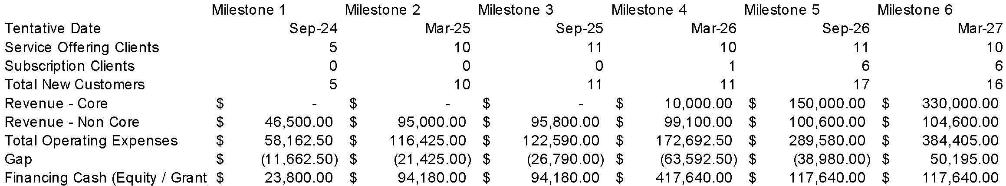

Phase 1 (Milestones 1 to 4 – months 1 to 21):
- Founder-led sales.
- Company is focused on R&D for its core product (SaaS subscription with AI).
- Company is offering non-core products: hourly services and custom engagements.
- Non-core products are generating revenue to sustain the company’s operations.
- Company has closed its pre-seed round.

Phase 2 (Milestones 5 and 6 – months 22 to 38):
- Product-led growth.
- Company is generating revenues from its core offering.
- Company is focused on growing user base.
- Company is adding sales team members, starting with sales executive and BDR.
- Company has closed its seed round.

Phase 3 (Months 39 onwards):
- Sustained Performance
- Company is generating enough revenue from its core offerings to sustain its operations.
- Company does not need to sell non-core offerings, such as hourly services or custom engagements, but it may keep these business units running.
- Company is achieving desirable profit targets (e.g., EBITA, ROI, Payback, etc.).
- Company has closed its Series A round.

The overall period for the financial plan is 33 months, starting from present July 2024 until July 2027. Ambient Systems envisions a period of 21 months to develop the commercial version of the product. This is the core product that can generate revenue based on the primary business model subscription-based SaaS offering. Operations during this period of time will be maintained with generating revenue non-core product offerings, such as hourly services and custom engagements as well as supplemented with fundraising from various sources, including Incubator Funding from HKSTP, RTH Scheme from the Government of Hong Kong, as well as private investors and other institutions in Hong Kong and internationally. This aligns with the milestone plan in Appendix A: Milestones. Given that Ambient Systems is an early-stage startup in the pre-launch phase, there is no historical information to conduct the sales forecast. This can be overcome by splitting up the offerings that the company plans to sell and creating corresponding financial plan for each scenario.

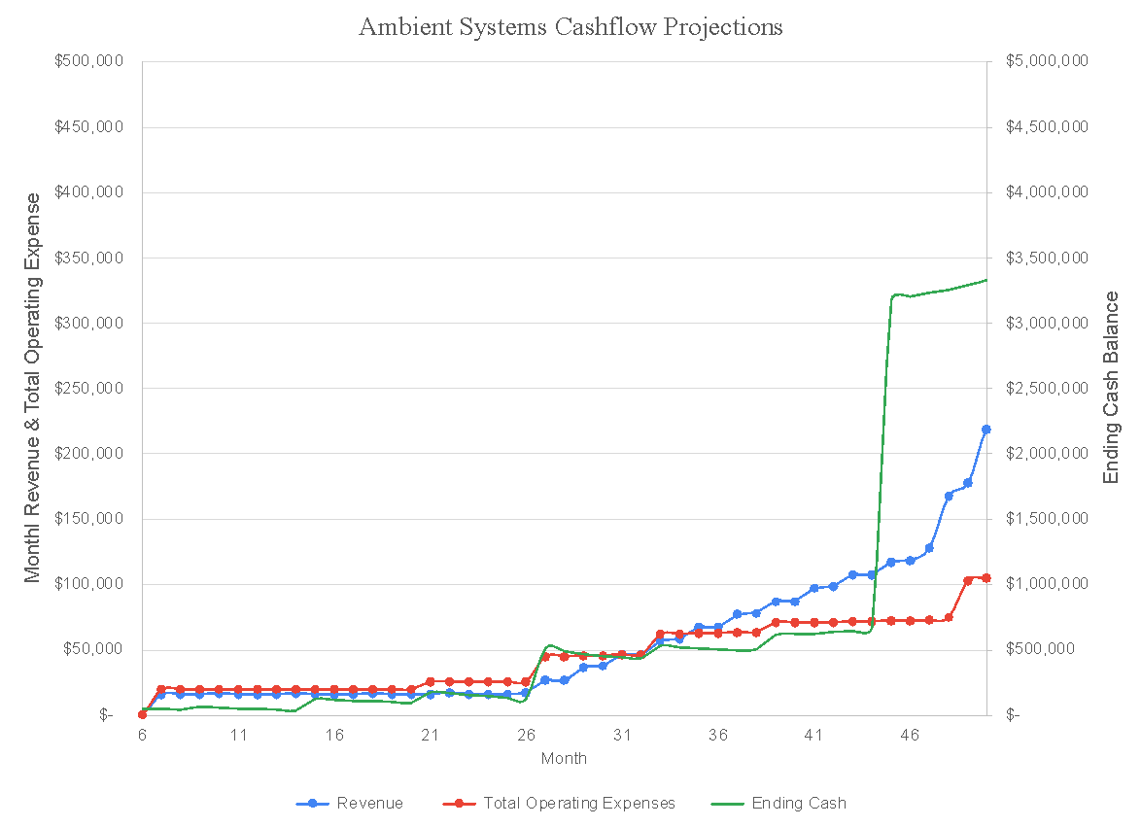

Sales Forecast: Ambient Systems will take a phased approach to growing its revenues, starting with an hourly and customer project revenue model before moving to subscription-based revenue model (i.e., SaaS). The reason for this is that the cost of developing the product with full features that the user can use through a subscription will require significant time and resource investment. Moreover, uncertainty about the market demand needs to resolve through customer validation. To reduce this risk, Ambient Systems aims to develop its platform gradually. This means we want to move from providing essential functionalities through the platform and gradually increase the scope and complexity of the solution, adapting the scope of features to the concurrent customer discovery discussions. We estimate that we can sell hourly or custom development services in the first Phase (until month 26) to sustain the business while we develop the commercial version of the product, gather customer validation, and complete pre-seed fundraising. This strategic approach indicates Ambient Systems ability to mitigate risk and ensure financial sustainability of Ambient Systems.

Fundraising Plan: To support its expansion and innovation initiatives, Ambient Systems plans strategic fundraising activities over the next five years. The fundraising plan includes a combination of grant funding, venture capital, and strategic partnerships.
- Year 1 (2024):
  - Secure second tranche of NUS GRIP Investment ($50k)
  - Secure HKSTP Incubator Grant
  - Secure RTH Schema Grant
- Year 2 (2025):
  - Secure pre-seed funding round between $300,000 to $500,000 for scaling operations and expanding the customer base.
- Year 3 (2026):
  - Maintain operations through revenues and funding through HKSTP Incubator Grant and RTH Schema Grant.
- Year 4 (2027):
  - Secure seed round between $2,500,000 to $4,000,0000 for further growth.
  - Maintain funding through HKSTP Incubator Grant and RTH Schema Grant
- Year 5 (2028):
  - Secure additional equity investments as needed through Series A round.

Financial Analysis

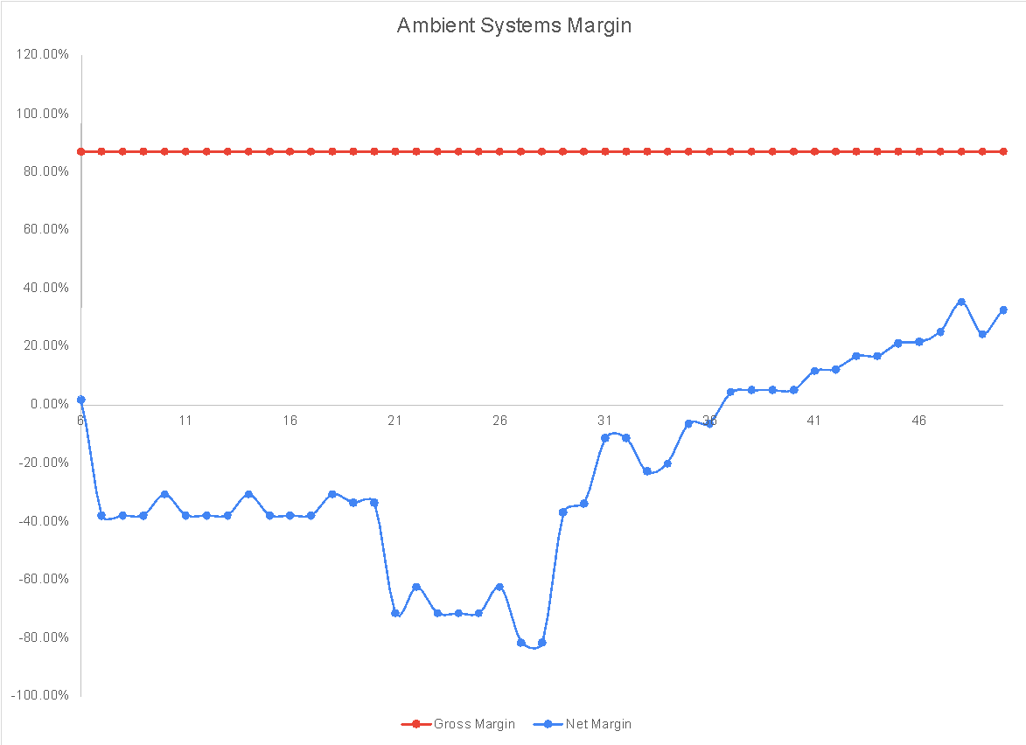

Ambient Systems foresees a steady gross margin of around 87% after accounting for 3% payment processing costs and 10% computing costs. At the same time, we see a steady improvement in the net margin once the product is developed and subscription revenues are being generated. In the early stages, net margins will likely be low or negative as we reinvest heavily in marketing, sales, and product development to fuel rapid growth. Net margins in this stage can range from 0% to -60%. In next stages of the company, we see the net margin steadily returning to 0% before rising to the high performing industry standard of up to 35%.

Sample Calculation ERP Solution Payback: Assuming mid-range development estimate of $1 million and monthly tentative subscription of $100. If we divide the total development cost of $1m by the estimated annual subscription amount of $1,200 ($100 per month * 12 months), we get 833 users.

The analysis suggests that while developing and launching an AI platform can be expensive and require a larger user base to achieve profitability, it also has the potential for higher revenue per user. ERP and FP&A platforms, on the other hand, can be launched with less upfront investment and may be more suitable for businesses with smaller budgets or a more targeted user base.

Here are some key takeaways from the analysis:
- Development costs: The cost of developing each platform varies significantly, with AI platforms being the most expensive and ERP platforms being the least expensive.
- Subscription fees: Monthly and annual subscription fees also vary, with AI platforms again commanding the highest prices.
- Number of users for payback: The number of users needed to achieve payback on the development costs is highest for AI platforms and lowest for ERP platforms.
- Benchmarks: The analysis also provides some benchmarks for each platform type, such as the number of users and pricing of similar solutions offered by existing companies.

Limitations include that analysis is done for a mid-range scenario and specific platforms are used for benchmarks.

Conclusion:

This financial plan serves as a dynamic guide for Ambient Systems operations, incorporating flexibility to adapt to market changes and growth opportunities. The projections are subject to periodic review and adjustment based on actual performance and evolving business conditions.

Section 6: Services of HKSTP Incubation Programme

- Financial Support: Financial support from the HKSTP Incubation Programme is a crucial component in sustaining and scaling Ambient Systems. This assistance enables us to allocate resources strategically, invest in talent acquisition, and meet operational costs during the critical early stages of our development. The financial backing ensures that we can navigate challenges and focus on achieving key milestones without compromising on innovation.

- Business Development Support & Services: Business development support offered by HKSTP significantly contributes to Ambient Systems' growth. Through this support, we gain access to state-of-the-art facilities and a network of industry experts. This accelerates our R&D processes, facilitates testing and validation of our solutions, and ensures that our products remain at the forefront of technological advancements.

- Office Space: HKSTP's provision of office space is instrumental in providing Ambient Systems with a conducive environment for innovation and collaboration. The dedicated office space offers a professional setting for our team to focus on R&D activities, conduct meetings, and foster a culture of creativity. This infrastructure is vital for building a cohesive team and optimizing productivity.

- InnoCell Facilities: The availability of living facilities as part of the incubation programme adds a practical dimension to Ambient Systems’ operations. This offering is particularly beneficial for team members relocating or working across borders, ensuring a seamless transition, and facilitating their focus on critical tasks. Comfortable and convenient living arrangements contribute to a positive work-life balance, promoting overall well-being and sustained productivity.

- HKSTP Shenzhen Branch: The access to incubation facilities at the Shenzhen branch enhances Ambient Systems’ market reach and provides strategic advantages. Shenzhen is a hub for technology and innovation, offering opportunities for collaboration, partnerships, and market exploration. The presence of a satellite office in Shenzhen positions Ambient Systems at the crossroads of the vibrant tech ecosystem, fostering connections that are invaluable for growth.

In summary, the comprehensive support provided by the HKSTP Incubation Programme, encompassing office space, technology and business development assistance, financial support, a strategic Shenzhen office, and living facilities, collectively forms a robust framework for Ambient Systems’ growth. These services not only address immediate operational needs but also position our company strategically within the innovation ecosystem, fostering long-term success.

Bibliography

[1] | The Business Research Company, "Financial Services Global Market Report," 2023.
[2] | Gartner Inc., "Software Market Insights: Accounting and Finance," 2022.
[3] | Polaris Market Research, "Financial Planning Software Market," 2021.
[4] | Oracle NetSuite, "Company Overview," [Online]. Available: https://www.netsuite.com/portal/aboutus.shtml#:~:text=NetSuite%20has%20everything%20you%20need,and%20territories%20around%20the%20world.. [Accessed 4 January 2024].
[5] | Yardi, "Our Clients," [Online]. Available: https://www.yardi.co.uk/about-us/our-clients/. [Accessed 5 January 2024].
[6] | Anaplan, "Anaplan Announces First Quarter Fiscal Year 2023 Financial Results," 26 May 2022. [Online]. Available: https://www.anaplan.com/news/anaplan-announces-first-quarter-fiscal-year-2023-financial-results/#:~:text=Based%20in%20San%20Francisco%2C%20Anaplan,more%20than%201%2C900%20customers%20worldwide.. [Accessed 5 January 2024].
[7] | Bloomberg, "AI Startup Hugging Face Valued at $4.5 Billion After Raising Funding From Google, Nvidia," 24 August 2023. [Online]. Available: https://www.bloomberg.com/news/articles/2023-08-24/ai-startup-hugging-face-valued-at-4-5-billion-after-fundraising. [Accessed 5 January 2024].
[8] | C3.AI, "C3 AI Announces Fiscal Third Quarter 2023 Financial Results," 2 March 2023. [Online]. Available: https://c3.ai/c3-ai-announces-fiscal-third-quarter-2023-financial-results/. [Accessed 5 January 2024].

Appendix

Appendix A: Milestones

 | Milestone 1 | Milestone 2 | Milestone 3 | Milestone 4 | Milestone 5 | Milestone 6
Time Period (Months) | 0 to 3 | 4 to 9 | 10 to 15 | 16 to 21 | 22 to 27 | 28 to 33
Tentative Date | September 2024 | March 2025 | September 2025 | March 2026 | September 2026 | March 2027
Product Development Progress
Design Work | Complete architecture diagrams, product designs, and user journey. | Identify requirements for AI model architecture, IOT integration, and financial management feature set. | Identify requirements for a pilot implementation based on customer interviews. | Hardware design improvements consisting of multimodal sensing, miniaturization, sensor fusion, Low-Power Wide-Area Networks (LPWAN) adoption, on-device AI implementation, alternative displays, and energy-efficient power supply |  | Internationalization of the product to different languages and regions
Prototype / Demo | Develop essential features. | Create standard connections between Ambient Systems and select ERP systems. | Create standard connections between Ambient Systems and IoT and telematics solutions. | Conduct field pilot study or studies with finance teams in construction, commercial real estate, and transportation companies in Hong Kong or GBA or SEA, demonstrating financial benefits of the comprehensive solution | Full scale implementation with one or more pilot sites. | Expand functionality to new use cases in financial operations like audit and new industry verticals like banking, asset management, and insurance.
Launch | Identify additional usability and launch requirements for Hong Kong and GBA, aligning them with global markets. | Conduct tests of the prototype. | Conduct alpha testing with priority users. | Conduct beta testing with external users during on-field pilot. | Fix any integration issues identified during testing. | Provide ongoing support and maintenance.
Business Development Progress
Activity - Number | 5 service offering clients | 10 service offering clients | 11 service offering clients | 10 service offering clients & 1 product subscription client | 11 service offering clients & 6 product subscription clients | 10 service offering clients & 6 subscription clients
Activity - Details | Secure customers for service and custom engagement offerings, complete Hong Kong market analysis, competitor mapping, and partnership discussions. | Strategic partnerships established, initial client engagements | Client acquisition campaigns | Intensive client acquisition, additional partnerships | Optimize client relationships, explore new markets | Global market entry, expanded partnerships
Partners  (Co Name & supporting document) | Current Partner  Panasonic IP Japan to provide relevant hardware tech for transportation sector. | Partner 2  Current accounting providers who can use Ambient’s technology. | Partner 3  Hong Kong regulators who can provide input on new technology. | Partner 4  Growth Partner who can help us reach more users more quickly. | Partner 5  Scalability partner who can help us tap into larger markets more quickly. | Partner 6  Capital partners who can help us attract more investment and funds for growth
Clients - Number | 5 | 10 | 11 | 11 | 17 | 16
Clients – Details  (Please provide names) | Clients in construction, commercial real estate, or transportation industries in Hong Kong and GBA.
Sales Revenue
Core product  (SaaS Subscription) | $0 | $0 | $0 | $10,000 | $150,000 | $330,000
Non-Core product  (Hourly & Custom Contracts) | $46,500 | $95,000 | $95,800 | $99,100 | $100,600 | $104,600
Corporate Development Progress
Awards - Number Awards - Details | Innovation Awards, Technology Awards, Startup Awards, FinTech Awards, Entrepreneurship Awards, Sustainability, Business Excellence, Customer Satisfaction Awards, Industry Specific Awards
Head Count - FT (Non- Tech) | 0 | 0 | 0 | 1  Sales Executive | 2  Sales Executive  BDR x 2 | 3  Sales Executive  BDR x 2
Head Count - FT (Tech) | 3  R&D Lead (Founder)  Software Developer  Data Scientist | 3  R&D Lead (Founder)  Software Developer  Data Scientist | 4  R&D Lead (Founder)  Software Developer x 2  Data Scientist | 6  R&D Lead (Founder)  Software Developer x 3  Data Scientist x 2 | 7  R&D Lead (Founder)  Manager x 1  Software  Software Developer x 3  Data Scientist x 2 | 7  R&D Lead (Founder)  Engineering Manager x 1  Software Developer x 3  Data Scientist x 2
Head Count - PT | 0 | 0 | 0 | 1  Marketing Manager | 1  Marketing Manager | 1  Marketing Manager
I.P. Application - Patent - Number | TBD | TBD | TBD | TBD | TBD | TBD
I.P. Application - Patent - Details | TBD | TBD | TBD | TBD | TBD | TBD
I.P. Application - Trademark - Number | TBD | 1 | 1 | 1 | TBD | TBD
I.P. Application - Trademark - Details | TBD | Ambient Systems trademark in Hong Kong | Ambient Systems trademark in China | Ambient Systems trademark in global markets | TBD | TBD
I.P. Application - Other filings - Number | TBD | TBD | TBD | TBD | TBD | TBD
I.P. Application - Other filings - Details | TBD | TBD | TBD | TBD | TBD | TBD

Appendix B: Company Overview and Strategic Evolution

Incorporated by Ivan Damnjanović and Ivan Damnjanovic in Singapore on July 5, 2021.

History and Milestones

Ambient Systems commenced its operations with a specific focus on addressing challenges in vertical farming, leveraging innovative technologies. This initial phase led to a strategic partnership with the National University of Singapore, resulting in a recognized patent by the World Intellectual Property Organization (WIPO) in 2022. The company's success in vertical farming laid the foundation for expansion into commercial real estate. During this phase, Ambient Systems not only gained international acclaim but also developed valuable intellectual property, showcasing its versatility and adaptability.

Strategic Pivot to Fintech

As the company delved into the intricacies of financial management within agriculture and real estate sectors, a broader realization emerged—a unique opportunity to revolutionize financial planning and management (FP&M) on a larger scale. This marked a strategic pivot for Ambient Systems, repositioning itself as a fintech innovator.

The transition into the fintech landscape aligns with the company's commitment to providing comprehensive solutions for diverse financial challenges. At the core of this strategic shift is the development of a cloud-based Financial Planning and Management Software (FP&M SW), integrating cutting-edge technologies such as AI and IoT. This evolution represents Ambient Systems' ambition to pioneer advancements in FP&M technology with a global perspective.

Current Objectives: Investments and Customer Onboarding

Ambient Systems is currently focused on two strategic objectives:
- Securing Strategic Investments: Actively seeking strategic investments to propel ongoing R&D initiatives, enhance the technology stack, and expedite market penetration.
- Onboarding Initial Customers: Dedicated to showcasing the tangible value of its FP&M SW by onboarding initial customers across diverse industries.

Key Achievements

The success of Ambient Systems is highlighted by several notable achievements:
- Emerging as the Panasonic Deep Tech Innovation Challenge Winner.
- Participation as a Startup Exhibitor at the inaugural City.Tech-Tokyo in 2023.
- Founder Ivan Damnjanović́ joining Antler Singapore Cohort 13, emphasizing the commitment to talent and innovation.
- International acclaim with a patent recognized by WIPO in 2022.
- Achieving First Runner-up in the Google Cloud Hackathon in Singapore in 2022.

Appendix C: Customer Problems

This section describes the individual customer needs identified from Section 1: Products & Solutions to Be Developed. These pain points are tailored for the use case in Transportation. However, similar pain points are faced by finance teams in other industry verticals where we previously conducted interviews. These include professional services, financial services, and pharmaceutical industries. Some of the details in new solution column will be unique to the operations of a transportation business. For example, data from cameras on vehicles can be used for certain finance-oriented goals. These hardware components, such as sensors, may be less critical for other use cases.

These problem domains are listed here and elaborated further in the following pages.

- Forecast revenues and expenses
- Long-term funding and investments
- Paying and managing taxes
- Cost control
- Managing cash flow and revenues
- Managing risks
- Ensuring compliance

 | List of Problems | Today’s Solution | New Solution
1 | Finance team needs to forecast revenues/expenses | The finance team gathers historical financial data (past revenues, expenses, etc.) and input from other teams. The financial data may be segmented for different revenue streams (e.g. group bookings, individual bookings, etc). The finance team analyses the market for external factors (travel demand, economic conditions (fuel process, GDP growth, etc), seasonality and demand trends (tourism, holidays, events, demographic changes, etc), competition, etc). The finance team breaks down the various cost components (fuel, insurance, labour, maintenance, marketing, overhead, inflation, etc). The data is consolidated into a spreadsheet with hardcoded formulas to generate a forecast. Forecasts may be generated for best-case/worst-case/moderate-case scenarios. Finance team updates forecast using actual data. | Cloud-based FP&M SW that can consolidate financial and operational data from multiple databases to analyze using AI and generate accurate forecasts for revenue and expenses, and provide recommendations based on the data. Leading to better decision making and profitability, etc.  Additional IoT and camera with data collection system may be employed to generate and utilize new and important information (e.g. passenger profiles, trip information, etc) for more accurate forecasting.
2 | Finance team needs to seek long-term funding and make investments | Finance team considers the long-term financial goals and objectives. They identify potential investment opportunities based on the strategic goals (e.g. acquire new buses, expand routes, upgrade systems, improve customer experience, etc.). They perform risk assessment associated with the investment (e.g. market uncertainties, regulatory changes, operational changes, etc.). Diversification may be used to mitigate risks. They perform cost-benefit analysis for each investment to determine if financially viable. They consider the financing options (e.g. internal funds, bank loans, issuing bonds, seeking investors, etc.). They calculate the ROI to determine if risk is justified. They monitor the performance to identify required improvements and corrective actions. They communicate with stakeholders about discussions and strategies. | Cloud-based FP&M SW that can budget for investment and quantify risks of investment opportunities based on financial and other data and project how to reach desired financial goals. Leading to improved decision making and profitability, etc.
3 | Finance team needs to pay/manage taxes | Finance team identifies applicable taxes (e.g. income, sales, payroll, carbon, etc) and stays informed about updates. They also identify tax deduction/credits (e.g. fuel costs, maintenance, depreciation, etc). They perform tax planning to minimize tax liability within legal requirements. They consolidate financial data and input from other teams to keep accurate data. They determine based on tax formulas (or tax compliance SW) the amounts to be paid and generate reports. They file taxes and issue payments according to the required timeline. They maintain documentation for auditing. | Cloud-based FP&M SW that can consolidate financial and operational data from multiple databases to analyze using AI and generate recommendations for tax deductions and tax amounts based on tax policies/formulas provided.
4 | Finance team needs to implement cost-control | Finance team consolidates historical financial data and budget from other teams. They identify possible costs to be reduced. They consider ways to reduce the cost (market research, alternatives, consultation, feedback). They initiate/purchase new cost-control initiatives. They evaluate impact of cost-control implementations. | Cloud-based FP&M SW that can consolidate financial and operational data from multiple databases to analyze using AI and generate recommendations for reduced costs based on constraints and operations. (E.g. reducing maintenance, insurance, fuel, delay). Expected impact of changes can the quantified.  Additional IoT and camera with data collection system may be employed to generate and utilize new and important information (e.g. driving behaviour, road condition, etc) in order to provide actionable recommendations.
5 | Finance team needs to manage cash flow | Finance team gathers financial data and budget from other teams. With the help of SW, they forecast the inflows and outflows over specified periods (e.g. quarterly) and determine potential cash shortage/surplus. They monitor and follow up on accounts receivable and accounts payable. They negotiate favourable terms with customers and suppliers. They send invoices to customers and follow up on overdue payments disputes. They approve expenses and avoid unneeded expenses. They establish credit limits and monitors credit terms. They may arrange short-term financing. They maintain the capital balance (assets vs liabilities) and liquidity. They ensure sufficient cash reserves. They manage debts and loans. They implement changes as required to sustain operations and growth. | Cloud-based FP&M SW that can consolidate financial data from multiple databases to analyze using AI and generate recommendations for sustaining effective cash flow and growth.
6 | Finance team needs to manage risks | Finance teams identifies various possible risks (e.g. operational, financial, regulatory market, reputational, etc) and determines impact and likelihood. They develop strategies to mitigate or minimize risks (e.g. preventive measures, contingency plans, response protocols, redundancy/alternative supply). They ensure sufficient insurance coverage (e.g. accidents, liability, property damage, etc). They may use financial instruments like hedging. They negotiate contractual terms with suppliers/customers to reduce risks. They keep up and comply with regulations to reduce risks. The have internal controls to prevent errors/fraud/mismanagement/etc. | Cloud-based FP&M SW that can consolidate financial data from multiple databases to analyze using AI and inform of potential risks to the company and deviations to forecasts.
7 | Finance team needs to ensure compliance | Finance team determines relevant regulations. They impose control to ensure compliance and necessary processes to support auditing. | Cloud-based FP&M SW that can consolidate financial data from multiple databases to verify datasets and identify potential anomalies in the data.  Additional IoT and camera with data collection system may be employed to check operational data for compliance (e.g. driving behaviour, bus operations)

Appendix D: Product Demo
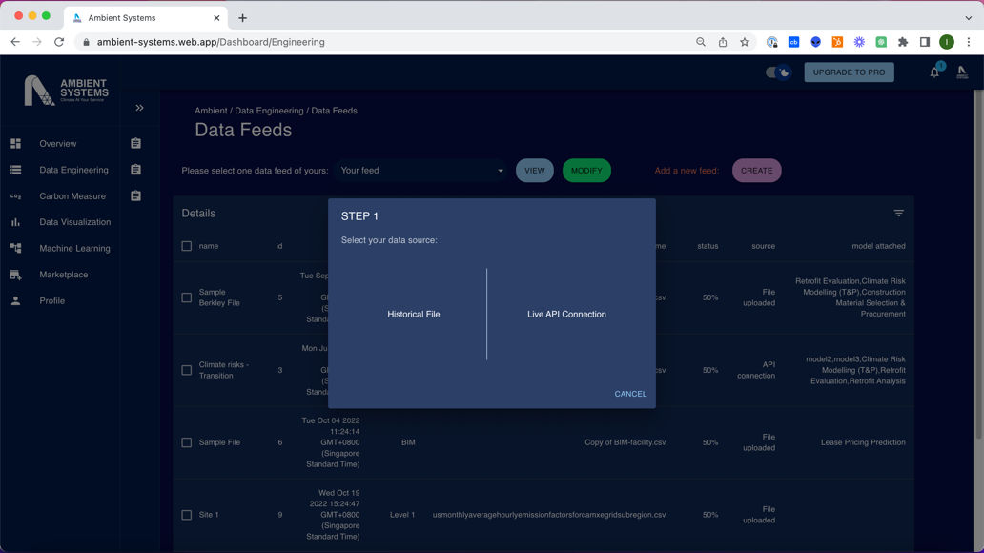

User Journey: Feature 1 – Combine Datasets
Connect existing platforms.
Connect traditional legacy databases without migration.

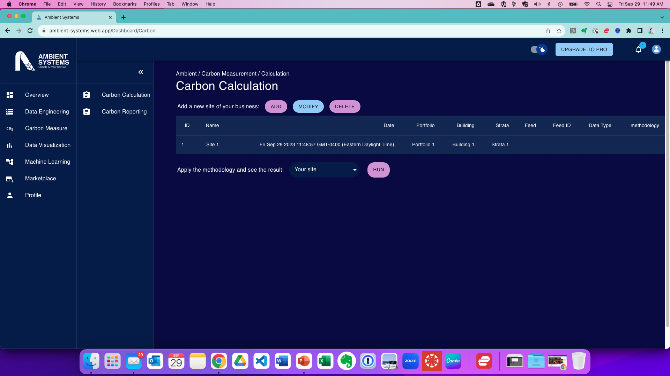

User Journey: Feature 2 – Automate Workflow
Key Features
Metric Library
Account Reconciliation
Auto-calculate Financial Performance Metrics
Compliance and Audit Reports

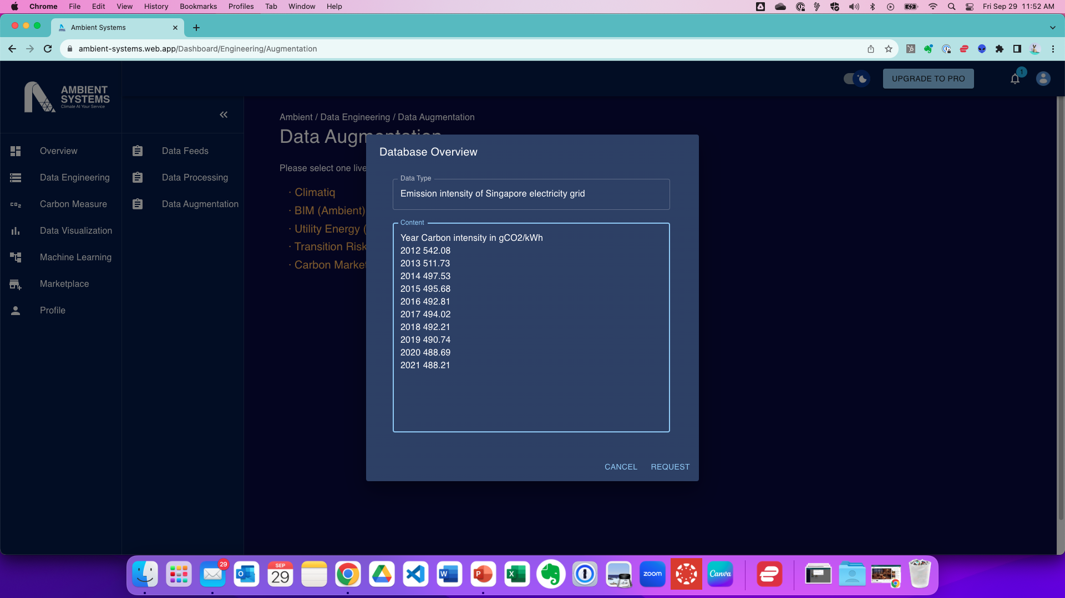
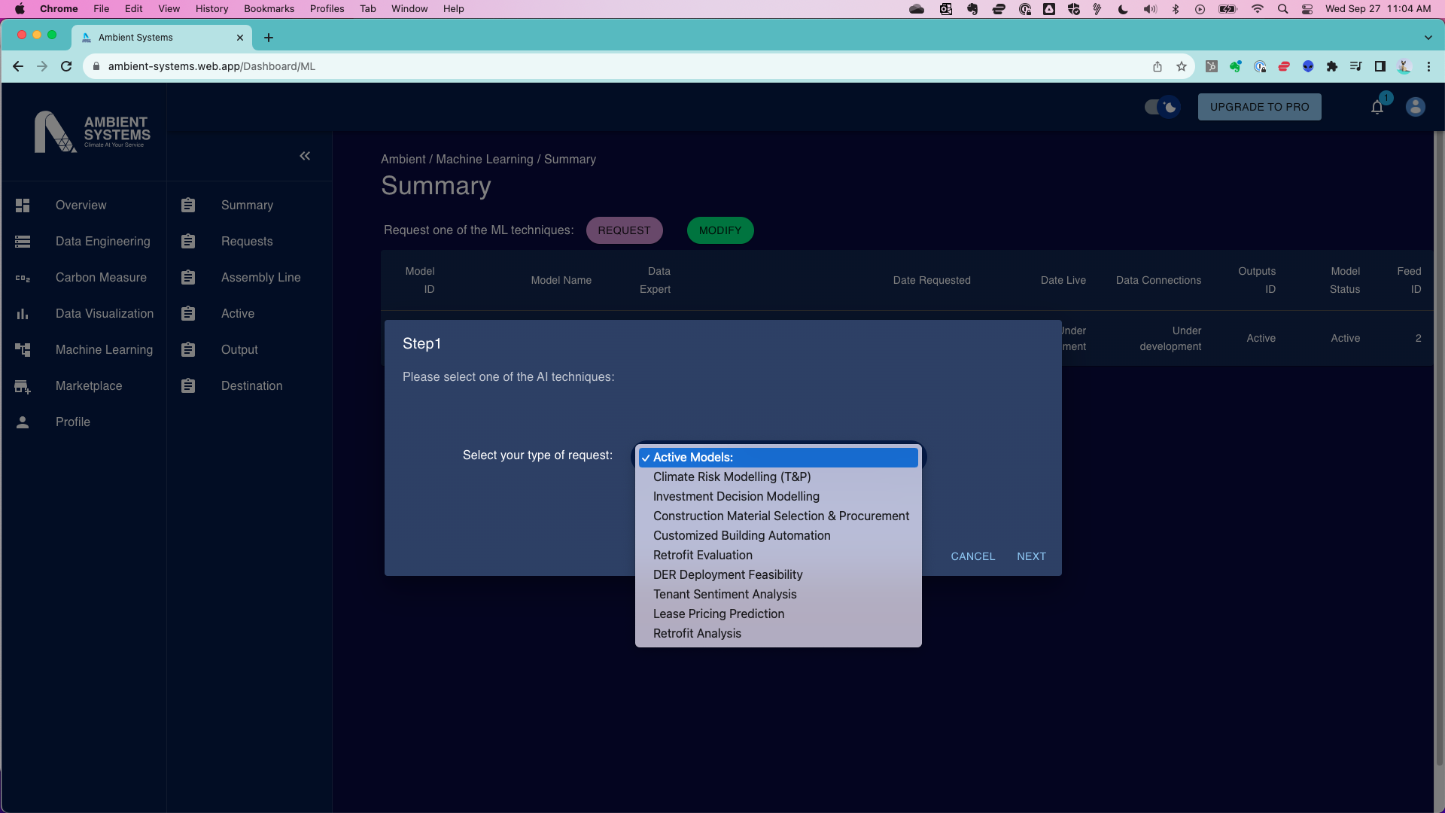
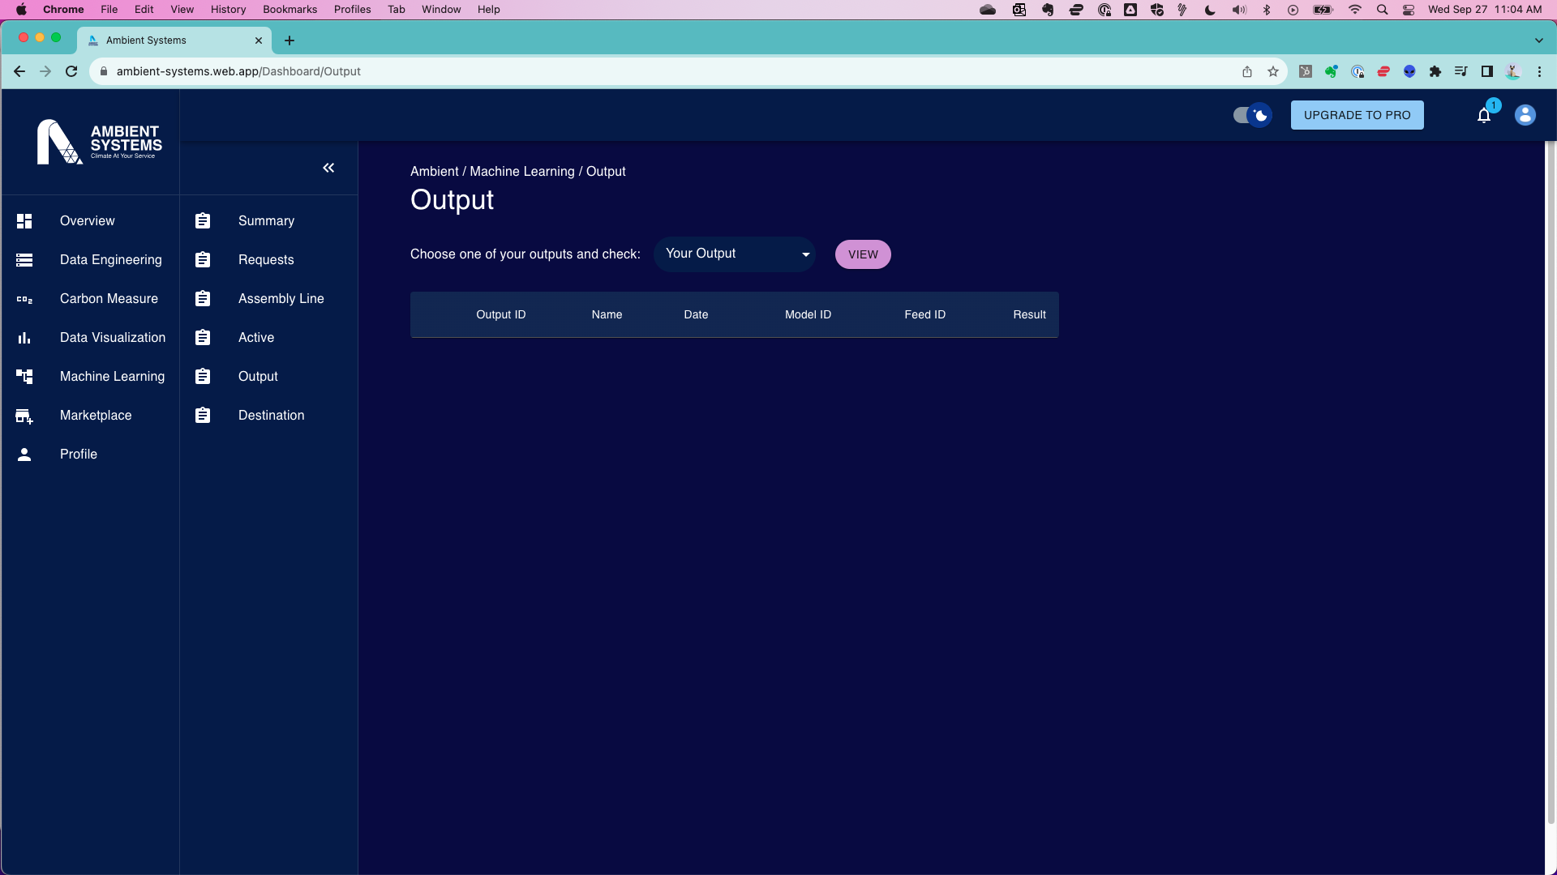

User Journey: Feature 3 – Add New Data
Key Features
New/Niche/Proprietary Datasets
Insightful Reports and Dashboards
Data Visualizations
Alerts and Notifications

User Journey: Feature 4 – Leverage ML and AI
Key Features
Request model
Select datasets.
Assign data science expert

User Journey: Step 5 – Output
Key ML Reports:
Predictions/Forecasts
Classification
Recommendations
NLP Outputs
Image/Video Output: Object detection, facial recognition, image captioning
Explanations/Interpretations

Appendix E: Technical Implementation Details

R&D Stream #1: Machine Learning Technology with Current State & Future State Analysis
Tech Category | Current State | Future Considerations | Technical Complexity
ML Framework | Utilizing an in-house ML framework or library (e.g., TensorFlow, PyTorch, Scikit-learn). | Exploring alternative frameworks for improved performance, compatibility, and additional features. | High: Assessing framework compatibility, migration efforts, and performance optimization.
Model Deployment | Deploying models using a serverless architecture using Vertex AI. | Exploring cloud-based deployment options such as AWS SageMaker, Google AI Platform, and Tencent ML Platform. | High: Adapting deployment pipelines, ensuring scalability, and optimizing inference speed.
Data Preparation | Utilizing in-house scripts and tools for data preprocessing. | Evaluating tools like Apache Spark, AWS Glue, and Tencent Cloud DataWorks for scalable and efficient data preparation. | Integrating new tools into existing workflows, ensuring data consistency, and optimizing preprocessing tasks.
Model Development | Utilizing an in-house ML framework or library (e.g., TensorFlow, PyTorch, Scikit-learn).  Deploying models on a dedicated server using Flask and Docker. | Exploring alternative frameworks for improved performance, compatibility, and additional features.  Exploring cloud-based deployment options such as AWS SageMaker, Google AI Platform, and Tencent ML Platform. | Assessing framework compatibility, migration efforts, and performance optimization.  Adapting deployment pipelines, ensuring scalability, and optimizing inference speed.
Model Training | Training models on local GPU servers with custom scripts.  Manual hyperparameter tuning using in-house scripts. | Exploring cloud-based training services like AWS SageMaker, Google AI Platform, and Tencent ML Platform.  Investigating automated tuning solutions like AWS Hyperparameter Optimization and Google AI Platform [Third party]. | Adapting training workflows, optimizing for distributed training, and managing costs.  Integrating automated tuning into existing workflows, optimizing for diverse models, and monitoring tuning performance.
[Third party] | Manual hyperparameter tuning using in-house scripts. | Investigating automated tuning solutions like AWS Hyperparameter Optimization and Google AI Platform [Third party]. | Integrating automated tuning into existing workflows, optimizing for diverse models, and monitoring tuning performance.
Model Evaluation | Employing custom evaluation metrics in post-training analysis.  Limited version control with manual tagging. | Considering cloud-based evaluation tools such as AWS Model Evaluation, Google AI Platform Evaluation, and Tencent ML Evaluation.  Exploring versioning solutions like DVC, MLflow, and Git-LFS for more structured model versioning. | Integrating new evaluation tools, ensuring consistency in metrics, and adapting analysis workflows.  Implementing version control processes, ensuring traceability, and adapting collaboration workflows.
Output | Currently printing results to the output monitor or text file. | Planning to create an output pipeline connection to various sources and formats.

R&D Stream #2: Technical Cloud Computing Details with Current State & Future State Analysis
Tech Category | Current State | Future Considerations | Technical Complexity
Cloud Service Provider | Current infrastructure is hosted on GCP, leveraging its advanced machine learning capabilities and services | Considering AWS for its extensive range of services and compatibility with China; exploring OVH Cloud for European presence; Tencent Cloud for access to the Chinese market. | Migrating infrastructure, ensuring data consistency, and optimizing performance in the new cloud environment.
Compute Resources & Scaling | Reliance on Google Compute Engine for virtual machine instances. | Exploring alternatives such as AWS EC2, OVH Compute, and Tencent Cloud VM for efficient and scalable compute resources. | Efficiently provisioning and scaling compute resources based on demand while minimizing costs and optimizing performance.
Serverless Computing | Serverless computing is implemented using Google Cloud Functions. | Exploring AWS Lambda and Tencent Cloud Serverless for efficient serverless computing. | Adapting applications to serverless architectures, optimizing function execution, and ensuring proper scaling.
Data Storage | Current data storage solutions are implemented using Google Cloud Storage. | Considering AWS S3, OVH Object Storage, and Tencent Cloud Storage for optimized data storage solutions. | Migrating existing data, ensuring data integrity, and optimizing storage costs in the new storage environment.
Database Services | Relational databases are managed using Google Cloud SQL. | Exploring AWS RDS, OVH Database, and Tencent Database as managed database service alternatives. | Ensuring seamless migration of databases, optimizing performance, and adapting applications to the new database services.
API Integration | Robust API integration capabilities are achieved using Google Cloud Endpoints/API Manager. | Planning to build easy-to-use standard connectors to enhance API integration capabilities. | Designing connectors that are modular, adaptable, and ensuring compatibility with diverse systems.
Monitoring and Logging | Current monitoring and logging solutions are based on Google Cloud Monitoring. | Considering AWS CloudWatch, Tencent Cloud Monitor, and potentially continuing with Google Cloud Monitoring. | Adapting existing monitoring and logging configurations, ensuring seamless transition, and maintaining visibility into system health.

Cloud Architecture Diagrams

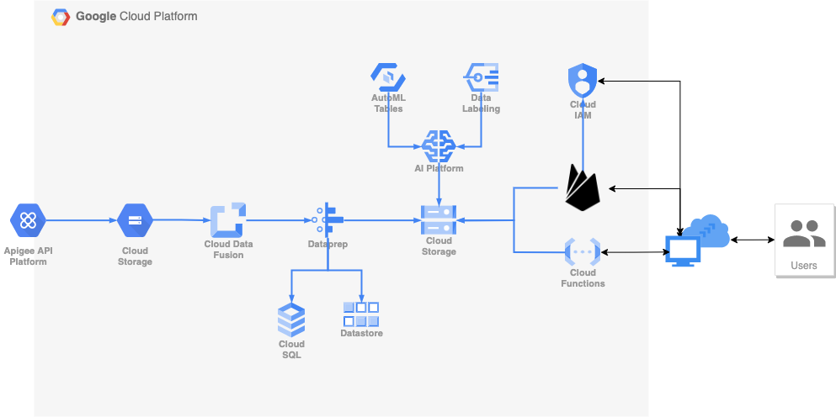
Current state (GCP Native)

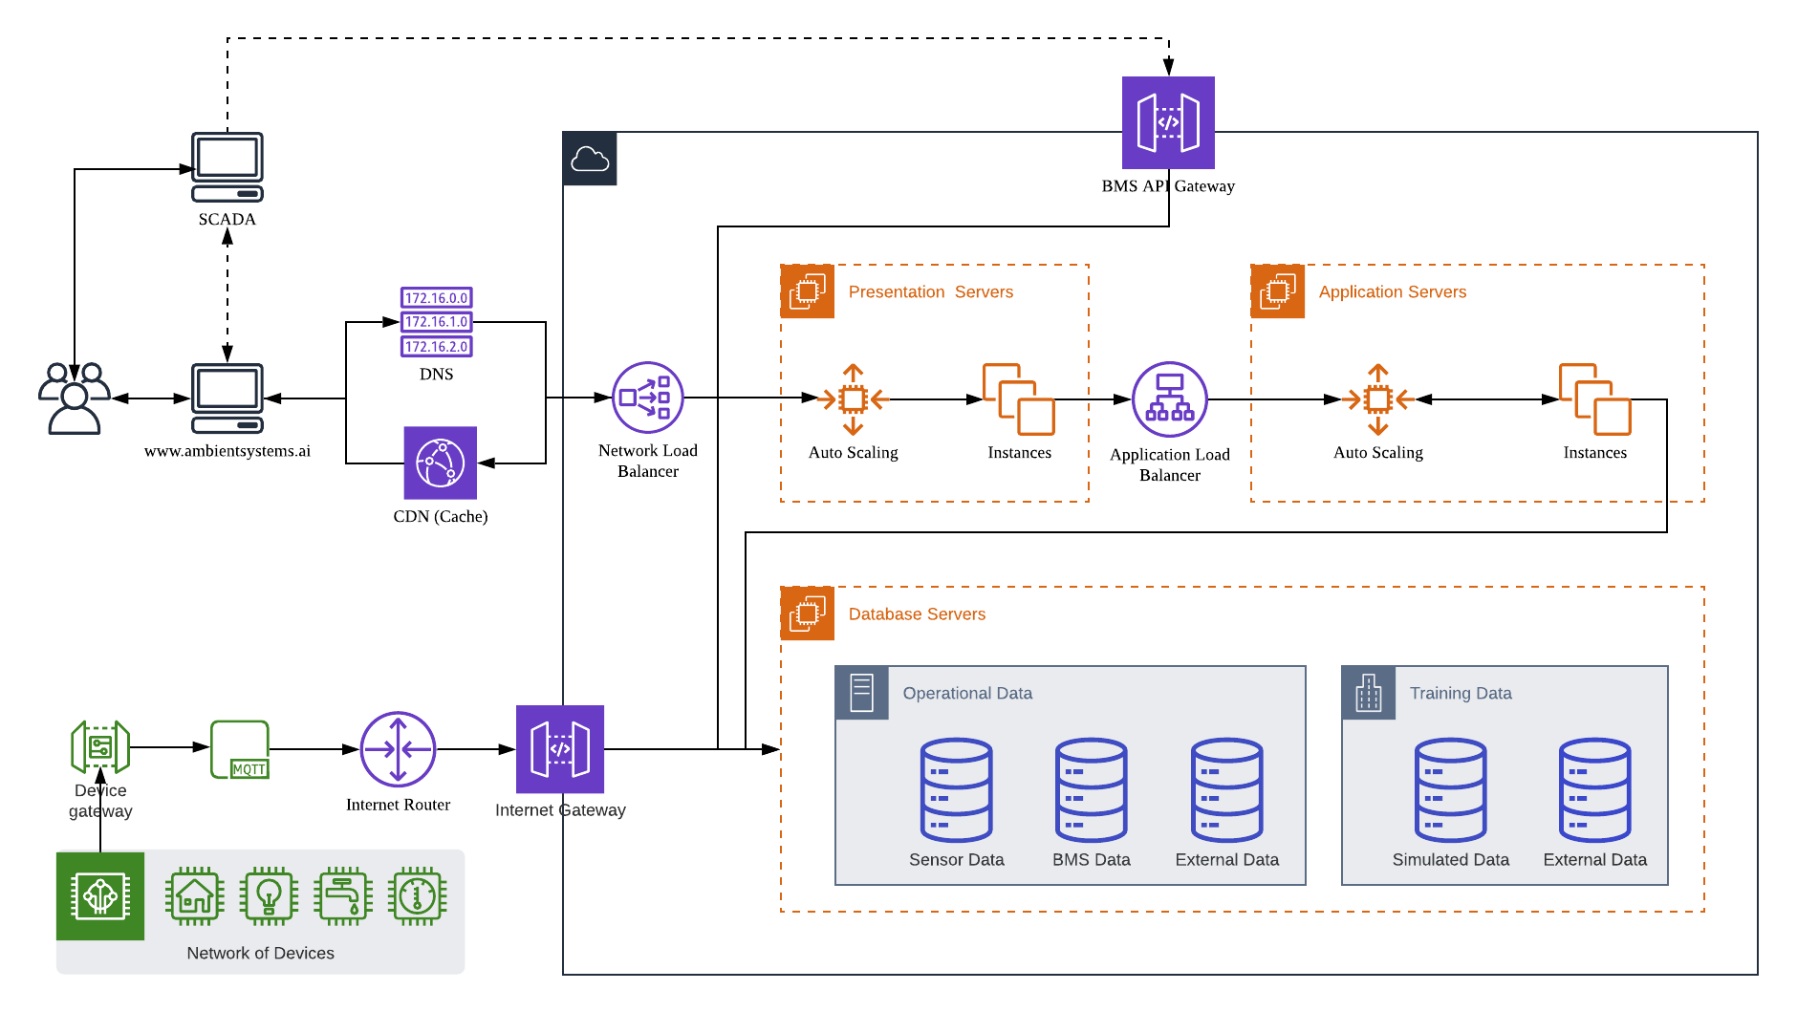
Current State (AWS Cloud Architecture with IoT Network)

Further to the technology stack, Ambient Systems has secured a patent in vertical farming. The architecture of the patent follows the following diagram. More information can be found through WIPO patent filing.

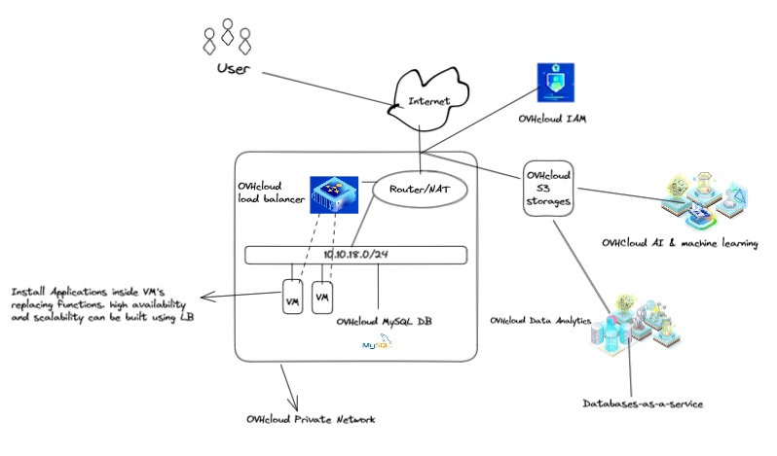
Future state (OVH Cloud Architecture for Cross-Border Compatibility and Performance)

R&D Stream #3: Hardware Technology with Current State & Future State Analysis
Tech Category | Current State | Future Considerations | Technical Complexity
Sensing Device | - Firebeetle 32 ESP32: Microcontroller for data acquisition and pre-processing (edge computing).  - Battery ([Third party]-ion 9000mAh): Long-lasting power source for remote deployments.  - Temp, Humi, CO2 sensor (Senserion SCD30): Environmental sensor gathering key data points.  - Light Sensor (BH1750): Additional sensor for contextual data. | - Multimodal Sensing: additional sensors like soil moisture, air pressure, or audio for richer data collection.  - Microcontroller Miniaturization: Smaller, more energy-efficient microcontrollers and sensors for compact deployments.  - Sensor Fusion: Combine data from multiple sensors for enriched insights. | Moderate – Requires knowledge of programming & electronics for customization.  Potential challenges include sensor calibration & accuracy maintenance, and data acquisition optimization for resource-constrained devices.
Connectivity | 4G Router: Provides internet access for cloud communication and data transmission. | - Low-Power Wide-Area Networks (LPWAN): Long-range data transmission for remote locations.  - Satellite communication: Global reach beyond cellular network coverage. | Moderate – Requires knowledge of network protocols & security configurations.  Potential challenges include: ensuring reliable & secure data transmission in diverse environments and power optimization for extended connectivity in disconnected areas.
Processing Unit | Raspberry Pi 400: Handles complex data analysis, decision-making, and user interface. | - On-device AI implementation: Real-time data analysis & intelligent actions without relying solely on cloud.  - Edge computing capabilities: Enhanced processing power & reduced reliance on cloud infrastructure. | High – Requires expertise in programming, data analysis, & AI implementation.  Potential challenges include resource management & processing optimization for resource-constrained devices and balancing cloud dependence with on-device AI capabilities.
Display | Computer Display: Visualizes data and insights for user interactions. | - Alternative display configurations: Consider touchscreens, e-paper displays, or even voice outputs.  - Dynamic data visualization: Adapt visualizations based on user preferences & context. | Moderate – Requires knowledge of display technologies & user interfaces.  Potential challenges include ensuring user-friendly & informative data visualization across different display options and optimizing power consumption for extended display operation.
Input | Wireless Mouse: Allows user interaction with the system.  Rasberry Pi 400 keyboard | * Alternative input configurations: Explore touch controls, voice commands, or gesture recognition. * User experience optimization: Adapt input methods based on application & user preferences. | Moderate – Requires knowledge of input technologies & user interfaces.  Potential challenges include designing intuitive & accessible input methods for diverse users & environments and balancing flexibility with power efficiency and security considerations.
Power | Power adaptor (For Rpi, 5v, 3A): Powers the Raspberry Pi.  Battery storage for sensing devices. | Energy efficient power supply to be explored. | Moderate – Requires understanding of power electronics & energy management strategies. * Ensuring reliable & sustainable power supply for long-term deployments. * Balancing power consumption with system functionality & performance.

System Diagrams (Hardware)

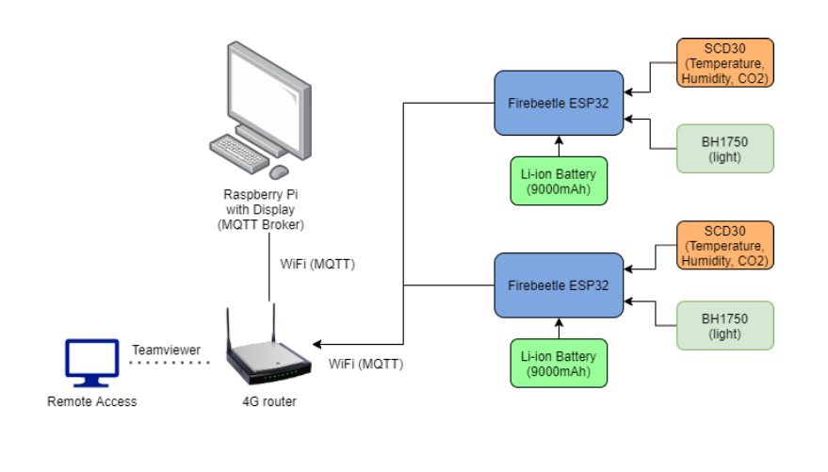
Current state (single use sensors)

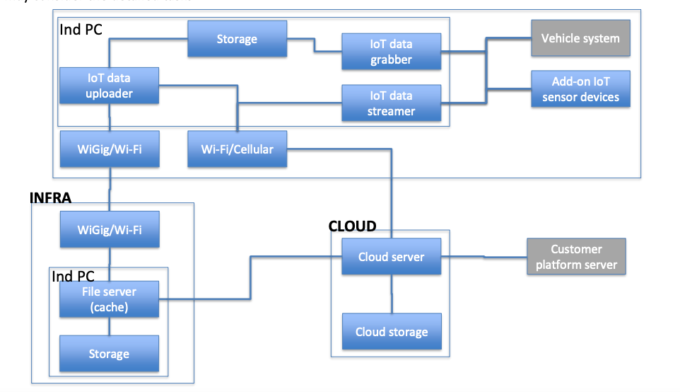
Future state (multi use sensors)

R&D Stream #4: Web Technology Stack and Tools with Current State & Future State Analysis
Tech Category | Current State | Future Considerations | Technical Complexity
Frontend Technologies | The React library, along with react-dom, is currently utilized for building UI components and rendering them in the DOM. | Explore latest React features; Adopt React concurrent mode. Optimize rendering for improved performance and user experience. | Moderate, adaptation to new features; testing for compatibility.
Frontend Technologies | Material-UI is employed for its core components (@mui/material), icons (@mui/icons-material), and utilizes @mui/styled-engine-sc for styling | Explore additional icon libraries; Optimize for icon usage. Stay updated with Material-UI releases; Optimize component usage. Consider alternative styling solutions; Optimize for performance. | Moderate, library exploration and integration. Moderate, staying aligned with Material-UI updates. Moderate, evaluating and implementing alternative solutions.
Frontend Technologies | PrimeReact is utilized for its UI components (primereact) and icons (primeicons). | Explore additional icon libraries; Optimize for icon usage. Stay updated with PrimeReact releases; Optimize component usage. | Moderate, library exploration and integration. Moderate, staying aligned with PrimeReact updates.
Styling Technologies | The Emotion library (@emotion/react) is used for styling React components, and styled components are created using @emotion/styled. | Explore new features in Emotion; Optimize for performance. Consider alternative styling solutions; Optimize for performance. | Moderate, adaptation to new features; testing for compatibility. Moderate, evaluating and implementing alternative solutions.
Styling Technologies | Styled-Components is employed as a library for writing CSS within JavaScript using components. | Stay updated with Styled-Components releases; Optimize styling approaches. | Moderate, staying aligned with Styled-Components updates.
Data Visualization and Charting | Recharts, a library for creating interactive and customizable charts in React applications, is currently used for data visualization. | Explore additional charting libraries; Optimize for performance. | Moderate, library exploration and integration.
Utility Libraries | The axios library, a promise-based HTTP client, is currently in use for making API requests. | Optimize API request handling; Explore alternatives for specific use cases. | Moderate, performance optimization; evaluating alternatives.
Utility Libraries | dayjs, a library for date and time manipulation, is currently utilized for handling date-related functionalities. | Explore new features in dayjs; Optimize for performance. | Moderate, adaptation to new features; testing for compatibility.
Utility Libraries | Firebase services and features are currently employed for various backend functionalities in the application. | Explore new Firebase features; Optimize for performance. | Moderate, adaptation to new features; testing for compatibility.

Appendix F: Market Segments

Phase 1 (Year 1 to Year 3)
Segment | Industry Vertical | Location | Accounts | Leads
Hong Kong Finance Team | Transportation (excluding aviation and maritime) | GBA: Hong Kong | 202 | 462
Hong Kong Commercial Real Estate | Commercial Real Estate | GBA: Hong Kong | 186 | 144
Finance Team | Financial Services, Insurance, & Investments | GBA: Hong Kong | 32 | 8k+
GBA – Real Estate | Commercial Real Estate | GBA: Shenzhen, Guangzhou, Macau, Zhuhai, Foshan Zhongshan, Dongguan, Huizhou | 229 | TBD
GBA - Transportation | Transportation (excluding aviation and maritime) |  | 455 | TBD
Management Teams | Vertical Farming | Global | 32 | 367
Total Accounts Phase 1 |  |  | 1.1k
Phase 2 (Year 4 to Year 6)
Segment | Industry Vertical | Location | Accounts | Leads
Finance Teams | Commercial Real Estate | Japan | 162 | TBD
All Teams | Transportation | Japan | 136 | TBD
Finance Teams and Sustainability Teams | Commercial Real Estate | Singapore/Southeast Asia | 13 | 610
Finance Teams | Transportation | Singapore/Southeast Asia | 16 | 164
Finance Teams | Commercial Real Estate | Canada | 2.5k+ | TBD
Finance Teams | Construction | Canada | 6k+ | TBD
Finance Teams | Transportation | Canada | 2k+ | TBD
Total Accounts Phase 2 |  |  | 47.5k
Phase 3 (Year 7 to Year 8)
Segment | Industry Vertical | Location | Accounts | Leads
Finance Teams | Transportation | US | 17k+ | TBD
Finance Teams | Transportation | UK | 3k+ | TBD
Finance Teams | Transportation | Europe | 17k+ | TBD
Total Accounts Phase 3 |  |  | 359

Appendix G: Competitive Landscape Analysis

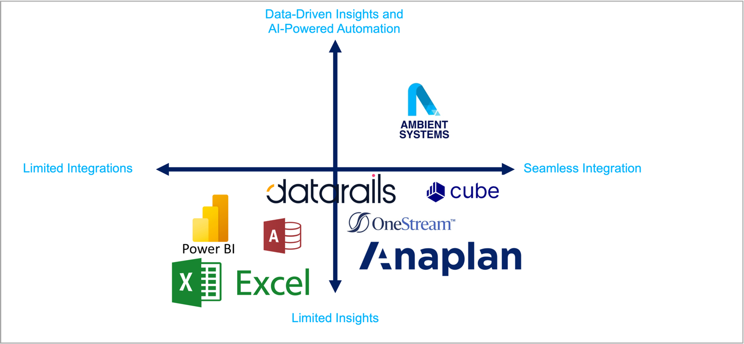

Key Takeaways:
- Ambient Systems occupies a unique position, combining both data-driven insights and seamless integration focused on financial management.
- Traditional CRMs/ERPs focus on operational data management and may not offer the same level of financial focus as Ambient Systems.
- FP&A software providers, such as Cube and OneStream, offer built-in AI features for querying data but lack seamless integration with existing systems and have limited insights for improving financial performance through organization-specific measures (e.g., ways to reduce energy costs at a building while improving worker productivity and comfort).

Quadrant 1 (Top Left):
- Advanced capabilities for analyzing financial data and generating insights but lack seamless integration with existing systems.
- They may require manual data consolidation or may not integrate well with other business systems, making it more challenging to achieve a unified view of financial data across the organization.
- This also includes ad-hoc and custom-made solutions for one-off data science projects that rely on single use data queries or temporary integrations.
Quadrant 2 (Bottom Left):
- Traditional solutions like spreadsheets and manual reports fall into the "Limited Integrations" and “Limited Insights” quadrant due to their inherent limitations in data integration and automation. These solutions rely heavily on manual data entry and analysis, making it challenging to maintain data accuracy and consistency across multiple systems and departments.
- While they offer powerful data analysis and visualization capabilities for small datasets, their reliance on desktop installations and limited integration with cloud-based enterprise systems restricts their ability to provide a unified view of financial data across the organization and restricts the volume of data that the system can handle as well as the speed of processing.
- Finally, they cater to all types of data and various user technical levels and interest, while Ambient Systems focuses on financial management.

Quadrant 3 (Bottom Right):
- Traditional CRMs/ERPs, such as SAP ERP, Oracle ERP, and Microsoft Dynamics, primarily focus on operational data management rather than financial planning and analysis.
- They provide strong capabilities for managing customer relationships, supply chains, and other operational processes, but they do not offer the same level of advanced financial modeling, forecasting, and risk management tools as Ambient Systems.
- Traditional FP&M solutions, such as spreadsheets and manual reports, also fall into this quadrant, relying heavily on manual data analysis and may not provide the same level of automation, efficiency, and data-driven insights as Ambient Systems.

Appendix H: Hiring Plan

Hiring Plan
- If the founder(s) will be the full-time staff of the company:
- A written declaration stating that the founders will quit their executive role(s) in their original company, that the arrangement is acknowledged by the board members, and commit to working full-time for the Hong Kong company if the company is admitted to the Programme.
- If the founder(s) is/are not eligible to work in Hong Kong, please submit your Working Visa Application and provide us with the visa application number(s)

- If the company is going to hire people to fulfil the MAC:
- A detailed hiring plan specifying which position(s) will be filled, including a job description or job posting (if available), and guaranteeing that at least two-full-time employees who can legally work in Hong Kong will be onboarded withed six months after receiving the condition offer of the Incubation Programme.

Ambient Systems aims to strategically expand its workforce over the next three years to support the company's growth objectives and emerging opportunities in the financial technology sector. The hiring plan outlines key areas for recruitment, including roles, skills, and timelines. The local hiring requirements will be met with two local staff.

Job Title: | Founder and R&D Lead (CEO)
Job Type: | Full-Time | R&D Related
Responsibilities: | - Lead the R&D team in developing and launching the FP&M SW, ensuring it meets the needs of target users and market trends.  - Articulate a clear and compelling product vision for the FP&M SW, aligning it with user needs and industry expectations.  - Conduct user research and gather requirements to define the functional and non-functional requirements for the FP&M SW.  - Prioritize features and develop a product roadmap that outlines the development phases and feature rollout.  - Oversee the technology stack and ensure the FP&M SW is built on a robust and scalable infrastructure.  - Evaluate and adopt emerging technologies to enhance the FP&M SW's capabilities and maintain a competitive edge.  - Establish and implement data governance policies and procedures to ensure the security and privacy of user data.  - Protect the company's intellectual property through patents, copyrights, and other legal means.  - Collaborate with industry partners to gain insights, access resources, and validate the FP&M SW concept.  - Engage with potential and existing customers to gather feedback, identify new opportunities, and build relationships.
Requirements: | - Master's degree in Computer Science or a related field.  - Understanding of target industries and markets, including but not limited to transportation, construction, and commercial real estate  - Proven track record of success in leading and managing R&D projects in the science and technology fields.  - Expertise in emerging technologies, including cloud computing, artificial intelligence (AI), and the Internet of Things (IoT).  - Strong product vision and ability to translate market needs into innovative product solutions.  - Exceptional communication and collaboration skills to work effectively with a diverse team of engineers, data scientists, and product managers.  - Passion for technology and a commitment to driving innovation in the financial services industry.

Job Title: | Software Developer / Engineer (Full Stack)
Reports To: | Founder and R&D Lead
Job Type: | Full-Time | R&D Related
Responsibilities: | - Design, develop, and test core functionalities of the FP&M SW, including financial data management, reporting, and visualization tools.  - Contribute to the development of wireframes, prototypes, and mockups to test and refine user interfaces.  - Participate in user testing and feedback sessions to identify and address usability issues.  - Collaborate with data scientists and product managers to integrate machine learning algorithms for financial forecasting, risk assessment, and anomaly detection.  - Write clean, maintainable, and well-documented code, adhering to industry best practices and coding standards.  - Conduct thorough testing to identify and resolve bugs, ensuring the FP&M SW meets quality and performance expectations.  - Contribute to the development of the FP&M SW's architecture and infrastructure, ensuring scalability and maintainability.
Requirements & Qualifications | - Bachelor's degree in Computer Science, Software Engineering, or a related field.  - Proven experience in designing, developing, and testing software applications in the financial technology industry or a related domain.  - Strong proficiency in programming languages such as JavaScript, Python, or  - Familiarity with cloud computing platforms, including GCP or Azure.  - Experience with data structures and algorithms, including object-oriented programming principles.  - Excellent problem-solving and analytical skills, with the ability to identify and resolve complex technical issues.  - Strong attention to detail and a commitment to writing clean, maintainable code.  - Effective communication and collaboration skills to work effectively with a diverse team of engineers, scientists, and product managers.

Job Title: | Data Science Associate / Analyst
Job Type: | Full-Time | R&D Related
Responsibilities: | - Collaborate with software engineers to integrate machine learning algorithms into the FP&M SW, ensuring optimal performance and accuracy.  - Develop and implement machine learning models for financial forecasting, risk assessment, and anomaly detection, utilizing deep learning techniques and statistical methods.  - Analyze financial data to identify trends, patterns, and anomalies, providing insights to inform financial decision-making.  - Evaluate the effectiveness of machine learning models and refine them as needed to improve accuracy and performance.  - Stay up-to-date with emerging trends and advancements in machine learning and statistical techniques, exploring opportunities to incorporate them into the FP&M SW.  - Contribute to research initiatives aimed at enhancing the FP&M SW's capabilities and exploring new applications of machine learning in financial technology.
Requirements: | - Master's or PhD degree in Data Science, Mathematics, Statistics, or a related quantitative field.  - Proven experience in applying machine learning and statistical techniques to real-world financial data analysis and problem-solving.  - Expertise in programming languages such as Python, R, or MATLAB.  - Familiarity with machine learning frameworks such as TensorFlow, PyTorch, or scikit-learn.  - Strong statistical and mathematical foundations, including probability theory, hypothesis testing, and regression analysis.  - Excellent communication and collaboration skills to work effectively with a diverse team of engineers, scientists, and product managers.  - Passion for data-driven solutions and a commitment to using machine learning to enhance financial decision-making.

Job Title: | Sales Executive
Job Type: | Full-Time | Non- R&D Related
Responsibilities: | - Develop and execute sales strategies to achieve individual and team targets  - Identify and qualify potential leads through market research, networking, and cold calling  - Prepare and deliver sales presentations to potential clients  - Negotiate and close deals  - Build and maintain relationships with key decision-makers  - Track and analyze sales data  - Provide feedback to management on market trends and competitor activities
Requirements: | - Bachelor's degree in business, marketing, or a related field  - 3+ years of experience in sales  - Proven track record of success in achieving sales targets  - Excellent communication and presentation skills  - Strong understanding of our target market  - Ability to work independently and as part of a team  - Highly motivated and results-oriented

Job Title: | Marketing Manager
Job Type: | Part-Time | Non- R&D Related
Responsibilities: | - Develop and implement comprehensive marketing strategies aligned with business objectives  - Conduct market research to identify target audiences, trends, and opportunities  - Create and manage marketing budgets  - Develop and execute multi-channel marketing campaigns, including digital, social media, email, and print  - Manage and oversee the creation of marketing materials, such as website content, brochures, and social media graphics  - Track and analyze marketing campaign performance and make data-driven recommendations  - Manage and mentor a team of marketing professionals
Requirements: | - Bachelor's degree in marketing, communications, or a related field  - 5+ years of experience in marketing management  - Proven track record of developing and executing successful marketing campaigns  - Strong understanding of marketing theory and principles  - Excellent communication, presentation, and interpersonal skills  - Ability to work independently and as part of a team  - Highly motivated, creative, and results-oriented

